**Summary:**

The Titanic Passenger Story will investigate the survival rate of its passengers. Which group has the highest survival group, and which group has the lowest.

**Data Chosen:**

The Titanic Data from this [Data Source](https://docs.google.com/document/d/1w7KhqotVi5eoKE3I_AZHbsxdr-NmcWsLTIiZrpxWx4w/pub?embedded=true). It contains the passengers’ information from a subset of 2224 passengers and crew on the Titanic.

**Design Plan:**

**Initial Design:**

<https://public.tableau.com/profile/siti6449#!/vizhome/TitanicPassengers_15/TitanicPassengers>

**Target Viewers:**

non-historians and non-statisticians. With this in mind, I’m designing a simple, straightforward story about the survival rate of the Titanic Passengers.

**Rough Sketch:-**

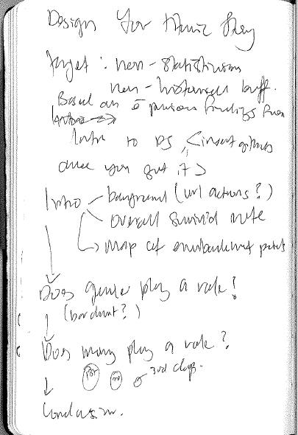

**Tableau Story Layout:-**

1st Storypoint: Introduction 🡪 2nd Storypoint: Gender Breakdown 🡪3rd Storypoint: Class Breakdown 🡪 4th Storypoint: Conclusion

**1st Storypoint Introduction**.

This page serves as an introduction to the viewer, and what they should expect when they go through the story.

There are three main components on this page:-

1. The Overall Survivors vs non-Survivors,
2. The Gender breakdown
3. The Class breakdown.

Viewers will be able to read the breakdown of these components in the next storypoint.

**2nd Storypoint: Gender Breakdown.**

In this page we will see a further breakdown based on Genders; how many females survived vs those who perished. Chart Type used: Side-by-Side Bar Chart. This chart type was selected as it allows to tell the huge disparity in genders when it comes to surviving the Titanic.

**3rd Storypoint: Class Breakdown.**

There’s two sides here; survivors vs non-survivors and it was denote with colours to differentiate the Passengers Class. Chart Type used: Bubble Chart. I wanted to make the visual more impactful. At one glance you can see the 3rd Class non-survivor has the biggest circle.

**4th Storypoint: Conclusion**

This is where we will bring both the genders and the class breakdown, and we will see which group had a high chance of surviving the Titanic. Chart Type used: Scatterplot. Scatterplot allows me to combine both the genders (denote by shape) and the class (denote by colours) in one panel. This allows the viewers to see the overall breakdown of the survivors and non-survivors.

**Feedback:**

Shared the below link to a fellow colleague of mine via WhatsApp. She opened it via her phone browser. These are her remarks:

* *It’s loading pretty slow in the phone browser*
* *The page seems to be breaking down and I can’t see anything.*
* *You can’t scroll anywhere to read this graph.*
* *What’s this supposed to show?*
* *At least I can read the title.*

Phone display as below:-

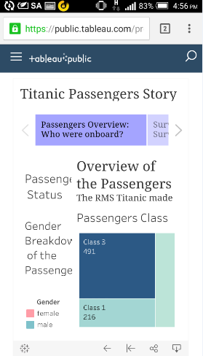

**Figure 1**: Tableau view on the phone browser. There are no scrolling panel anywhere.

However, she can follow the story pretty well in her laptop. She was able to understand the story as she remarks:

*‘the facts are pretty straightforward and it’s nice to be able to bring your mouse to highlight stuff’.*

She has also managed to identify the highest survival group:-

*‘A lot of the survivors are females.’*

**Design Improvements:**

Based on the feedback above, she can understand the story and the data involved. I will not make any changes on the information displays or chart type, however, I need to find a way so that the Tableau Story can be viewed in her phone browser.

Design changes:-

1. Fitting the Tableau dashboard so it can be viewed in both smartphones and tablets
2. The Tableau dashboard was embedded in the phone browser, hence I have to work with Small Blog Embedded template in my Tableau Story.

At the moment, viewers are not able to take out the Tableau dashboard from their phone browser. Unlike the desktop version, the mobile version does not have a Full Screen display. I’m keeping with my previous design and implementing the scrollbar in the mobile version.

The phone browser display after design changes:-

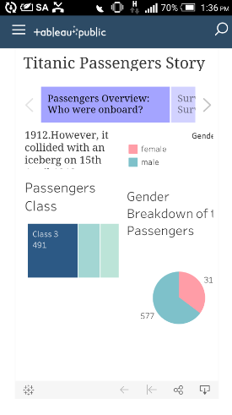

**Figure 2**: Tableau phone display after design improvements were made. There is an option to scroll in this story.

This design allows the smartphone users to scroll the dashboard anywhere they want. And it is also viewable in the desktop browser:-

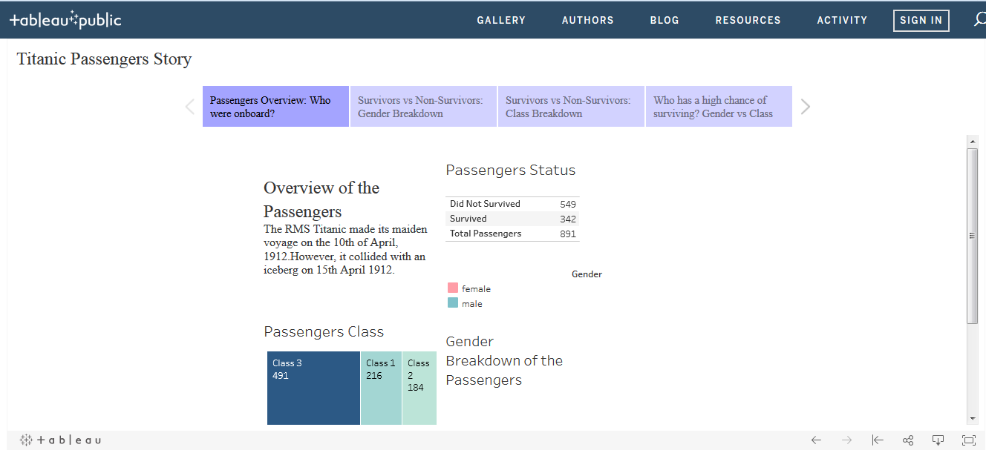

**Figure 3**: Tableau display on Desktop browser

**2nd Tableau link:**

<https://public.tableau.com/profile/siti6449#!/vizhome/TitanicPassengersv3_0/TitanicPassengers?publish=yes>

**Second Feedback:**

The second feedback came from Udacity reviewer after the first project has been submitted. They stated:-

*1- We are willing to see the visualization is self-explanatory so I would recommend using the story captions (top panels) to explain the story you want to share with us. Check this*[*story*](https://public.tableau.com/profile/mat.leonard#!/vizhome/shared/8B7RH9JPC)*. You can see how the author has used the story captions to explain the story behind the visualization. This change will help the reader to engage with your finding and communicate better with the visualization.*

*2- The colors used in the pie chart are not color-blind friendly. I highly recommend using color-blind friendly colors. The following chart shows some of the indistinguishable colors for people with this disorder.*

**Design Improvements Part 2:**

I made some of the changes on the Tableau Story based on the second feedback:-

1. Amending the Story captions so it can support the findings in the visuals.
2. Changing the colour palette to make it more colour-blind friendly.

This version can also be viewed in both phone and desktop browser.

**Latest Tableau Link:**

<https://public.tableau.com/profile/siti6449#!/vizhome/TitanicPassengersv4/TitanicPassengersStory?publish=yes>

**Resources:**

How to use device designer for your Dashboard:

<https://www.tableau.com/about/blog/2016/6/device-designer-56018?__src=liftigniter&__widget=blog-widget&li_source=LI&li_medium=blog-widget>

Colourblind Palette in Tableau:

<https://www.tableau.com/about/blog/2016/4/examining-data-viz-rules-dont-use-red-green-together-53463>